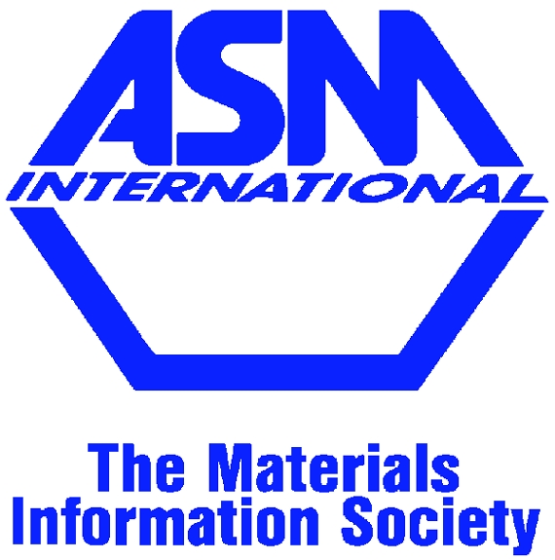
Looking for Nominations

Recent Geisler Award Recipients:

Nominations for the Geisler Memorial Award must be submitted by 1-April-2024 to Peter Hoskins, 212 3rd St., Apt. 4D, Troy, NY 12180, phoskins@blaschceramics.com
Nominations are being sought for the Alfred H. Geisler Memorial Award. The Geisler Award recognizes an outstanding young materials engineer from the Eastern NY ASM Chapter. Candidates should have made significant contributions in the fields of education, research, or manufacturing, before the age of 40. Nominations should include at least two letters of reference and a description of the nominee’s accomplishments. Nominations will be considered in the year they are submitted, and for the following two years.
- Eastern NY ASM Chapter 2024 Geisler Memorial Award

2021 Andrew Hoffman | 2020 Chaitanya Ullal | 2019 Jian Shi
2018 Soumya Nag | 2017 Elaine West | 2016 Akane Suzuki
2015 Ying Chen | 2014 Andrew Detor | 2013 Liping Huang
2011 Julie Tucker | 2010 Dan Lewis | 2009 Ed Richey
2008 Liang Jiang | 2006 Daniel Gall | 2005 Steve Attanasio
2004 George Young | 2003 James A. Ruud | 2002 David S. Morton
2001 Ji-Cheng Zhao | 2000 Linda Schadler

The Eastern NY Chapter of ASM International is offering one undergraduate scholarship award and one graduate scholarship award of $1,000 each. The scholarships are available to students studying in the materials science and engineering discipline. Material Advantage Student Membership is required for consideration. See next page.

Application forms must be submitted by 1-April-2024 to Peter Hoskins, 212 3rd St., Apt. 4D, Troy, NY 12180, phoskins@blaschceramics.com

- Eastern NY ASM Chapter 2024 Academic Scholarships

Eastern NY ASM Chapter 2024 Academic Scholarship Application
Fill out completely. Please TYPE or PRINT clearly. All materials must be submitted in English.

1. ____ Miss ____ Mrs. _____Ms. _______Mr. Full Name: ____________________________________________________________________

2. Indicate preferred address for contact and mailing: Address: ______________________________________________________________________ Address: ______________________________________________________________________ City/State/Zip Code: _____________________________________________________________ Telephone: _____________________________________________________________________ Email: ________________________________________________________________________

3. Material Advantage Student Member Number: _______________ Joint Date (Mo/Yr): ______

4. Country of Citizenship: _________________________________________________________

5. College or University: __________________________________________________________

6. _____Sophomore ______Junior ______Senior _______Graduate Student

7. Major/Concentration: __________________________________________________________

Attachments:
A. Current academic transcript through the fall term (an unofficial online copy is acceptable).
B. Employment Experience (Resume or CV)
C. A personal statement describing interest in metallurgy and/or materials, career plans, leadership roles, special achievements and honors, employment experience, and community involvement (maximum of two typewritten, double-spaced pages).
D. No more than two letters of recommendation from faculty/advisor/mentor/employer. One must be from a professor in applicant’s department of study.
E. A photograph to be used for publication of award winners. Photograph will not be part of the selection process.
Please sign below if this application and all attachments are complete and accurate:
Signature: _________________________________________ Date: _________________

